Lab 2
MATLAB + RTDE Installation and Setup for UR e-series Robots

Overview
This lab provides the steps to set up direct external control of a UR robot from MATLAB via the RTDE (Real-Time Data Exchange) protocol. Complete Lab 1 (UR Teach Pendant and Safety) before starting. The required prerequisites are listed below.

- Ethernet cable
- PC running Windows 10/11
  - Mathworks MATLAB installed
  - Install Robotics System Toolbox for Universal Robots UR Series Manipulators
- UR Robot Manipulator running PolyscopeX

Part 1 - Installing the URCapX on the Teach Pendant
To add external files to the Teach Pendant, you must first install software called a URCapX (a plugin for UR robots). It may already be installed on the robot, check this by doing the following:
- ☰ → System Manager → URCaps
- Check for an item called “ScriptFileSelector”
- If you see it there, move on to Part 2
If you do not see the ScriptFileSelector in the URcaps, follow the steps below to install it:
- Download the script-file-selector-1.0.0.urcapx from the FLLU-UR GitHub repository.
- Load this file onto a USB thumb drive.
- Insert the USB into the Teach Pendant in the slot shown below.
- Once inserted, power on the robot (or restart it if it was already on).
- On the Teach Pendant, navigate to the URCap Installation menu by tapping the menu icon, System Manager, URCaps.
- Tap the blue + URCap button.
- Select the script-file-selector-1.0.0.urcapx file.
- Wait for it to finish installing. You may need to restart the robot to complete the installation.
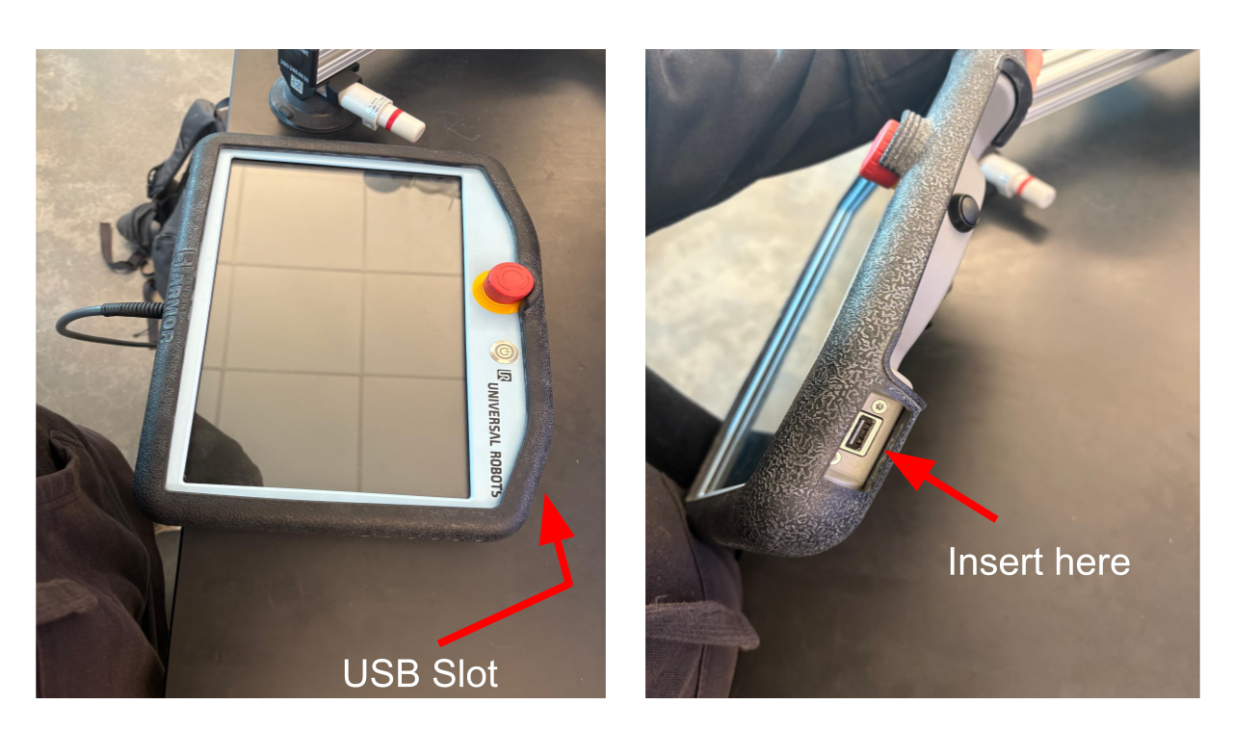
Figure 1 - Location of the USB slot on the Teach Pendant.

Part 2 - Copy URServerScript.script to USB thumb drive
The URServerScript.script file allows MATLAB to communicate with the robot over RTDE. It may already be on the robot. To check, do the following:
- Tap Program in the left sidebar
- Check if there is a node in the program tree, under Main Program, that is called:
  - Script Code: URServerScript.script
- Every group adds its own copy of the script to its own program tree, even if a script node is already there from a previous group. Create a new program tree for your section (e.g., “Semester 2026”) by tapping the program name at the top of the screen, then continue with the steps below
- Open MATLAB on your laptop and run the following two commands in the Command Window.
installationFilePath = fullfile(codertarget.urseries.internal.getSpPkgRootDir,'resources')
cd(installationFilePath)
- This stores the directory in a variable called installationFilePath.
- Print the variable's content using disp(installationFilePath)
- Navigate to the resulting directory in your File Explorer on your computer and copy the URServerScript.script file onto your USB thumb drive.

Part 3 - Adding the Script Node
To allow external communication with the URServer script, add it as a Script Code node in the program tree on the Teach Pendant.
- Insert the USB thumb drive containing the URServerScript.script file into the Teach Pendant slot.
- Tap Program in the left sidebar to reach the Program Tree.
- Tap the 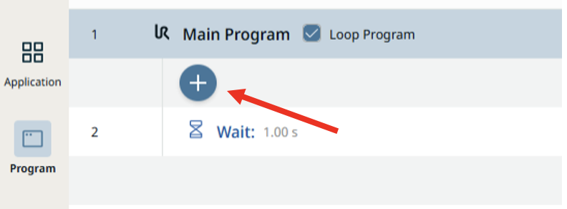 icon below in the Main Program line to add a new node.
Figure 2 - Adding a node to the Program Tree.
- Select the Script Code node.
- Once the node is in the Program Tree, tap the node and then tap the yellow “Select File” button as shown below in Fig. 3
- If not already in the USB directory, select your USB device from the sidebar
- Select the URServerScript.script file from your USB device
- Press “OK”
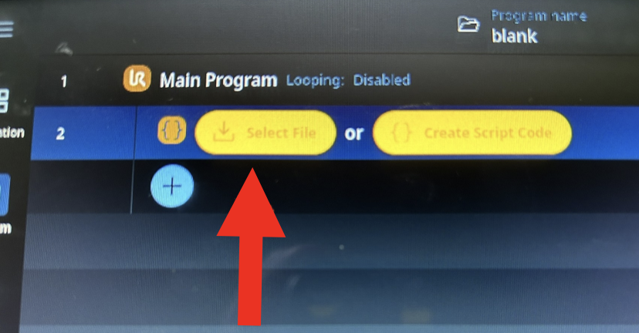
Figure 3 - Selecting the file from the Script Code node.
Note: the URCapX has a known display bug. The OK button is sometimes cut off the screen. Double-tap the file to select it instead if needed.

Part 4 - Networking
To allow communication between the PC and the robot, you must configure the IP addresses and subnet masks on each device and enable RTDE on the Teach Pendant.

Task 1: Configure the Teach Pendant
- Navigate to the settings menu by tapping ☰ → Settings.
- Tap Services under the Security submenu.
- Unlock this page using the robot admin password.
- Flip the switch for RTDE.
- Close and save.
- Tap Network under the Connection submenu.
- Select Static.
- Set the IP address to 192.168.0.20.
- Set the Subnet Mask to 255.255.255.0.
- Set the default gateway to 0.0.0.0.
- Tap Apply Configuration and close.

Task 2: Configure the PC
- Connect the ethernet cable from your computer to the control box.
- Follow this guide to set a static IP for your Ethernet port on the PC (admin rights needed).
- Use any IP on the same subnet as the robot, for example 192.168.0.10.
- Use subnet mask 255.255.255.0, matching the robot.

Task 3: Test the Connection
- Open a PowerShell terminal on the PC.
- Run the command below.
ping 192.168.0.20
If the connection is successful, you will see four reply lines.
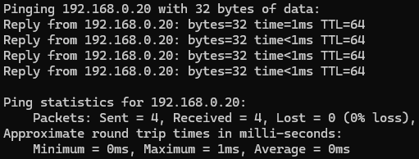
Figure 4 - Successful ping output communicating between the PC and robot

Part 5 - Configuring the Computer
Now that you have a network connection, configure the Robotics System Toolbox Support Package for Universal Robots UR Series Manipulators.
- Open MATLAB.
- Open the Add-Ons Manager by clicking the dropdown menu on the Add-Ons icon and selecting Manage Add-Ons.
- Scroll down to Robotics System Toolbox Support Package for Universal Robots UR Series Manipulators.
- Click the Options icon (the gear icon).
- The Hardware Setup window will open and provide step-by-step instructions for configuring the support package.
- Follow the instructions on each page. If successful, the window will show the live joint angles of your robot. Your PC and robot are now ready to send and receive commands over RTDE.

Part 6 - Sending Commands from the Computer
⚠️ WARNING!!! Robots are dangerous. Before we move the robot, please adhere to the following safety instructions:
- Keep the area around the robot clear of objects and persons
- Have the e-stop on hand at all times when moving the robot
- For this lab, put the robot speed to 25% using the slider in the bottom right of the TP screen
- Make sure the suction cups are activated if using a benchtop robot
  - Press the pistons on the sides of the cups repeatedly until a seal is made
Now that we have ensured our safety, boot up the robot and unlock the arm exactly as you practiced in Lab 1, Section 2: Power button, then Power On, then Unlock. THE ARM IS NOW ACTIVATED AND READY TO MOVE.

Moving the Arm
Always move the arm back to the Home Position before sending new commands.
Navigate to the right sidebar and tap Move → Smart Skills → Home, as you practiced in Lab 1.
Next, run the server script.
- Navigate back to the Program Tree and press the Play button at the bottom of the screen.
- The Script Code node in the Program Tree should turn green, indicating that the server script is running and ready to accept commands.
Using your MATLAB program, make a new .m script file, copy/paste to run the following code below, and run it to move the elbow joint 5 degrees and back.
%% RTDE Initialization
robotIP = "192.168.0.20";
ur = urRTDEClient(robotIP);
%% Read live joint angles (radians -> degrees for sanity)
anglesRad = readJointConfiguration(ur); % six-element vector
anglesDeg = rad2deg(anglesRad)
%% Move the elbow +5 deg and come back
target = anglesRad;
target(3) = target(3) + deg2rad(5); % bump joint 3
sendJointConfigurationAndWait(ur, target); % block until done
sendJointConfigurationAndWait(ur, anglesRad); % return

Part 7 – Power Down Sequence
Always follow this procedure to power down the robot:
- Move the robot back to Home position (Move → Smart Skills → Home)
- Press the power button on the TP

Part 8 – Extra Resources
- Real Time Data Exchange User Guide

